**Final Year Project**

B.E 2016

**Intelligent Traffic Control System**

**Results and Description**

**Swati**

**5.1 RESULTS**

**CASE 1:**

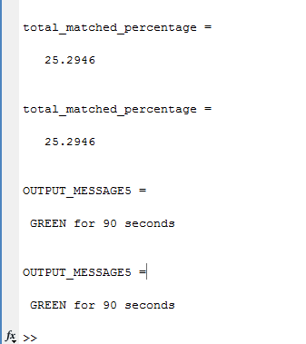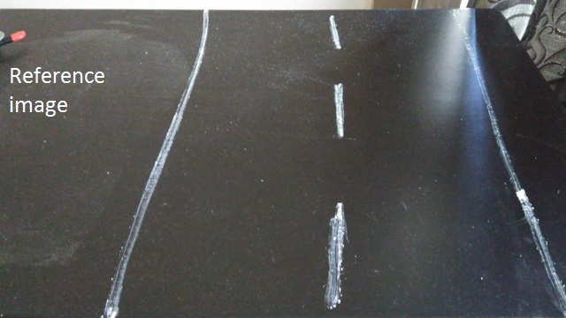

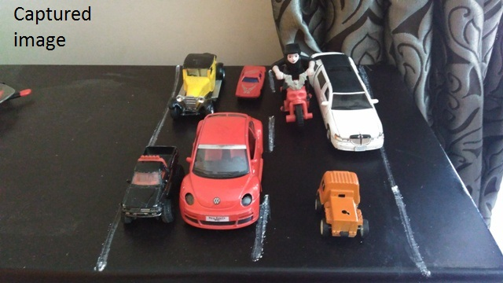

**CASE 2**



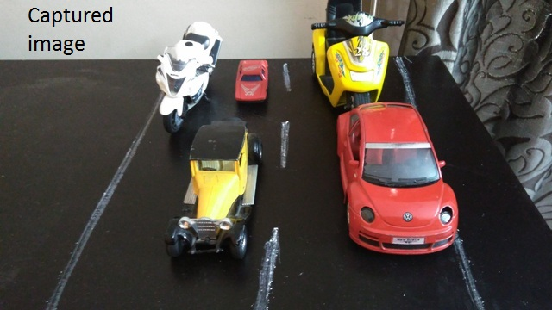

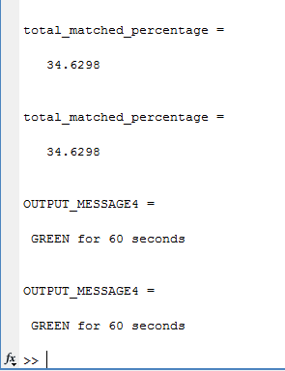

**CASE 3**



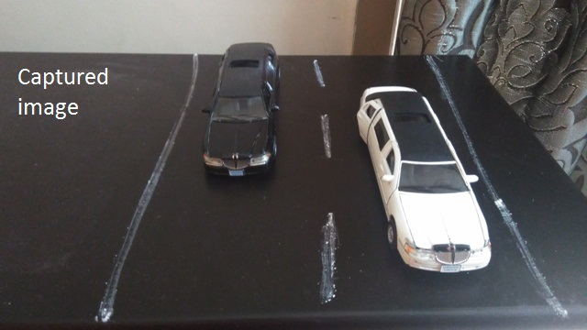

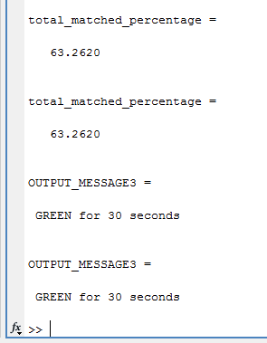

**CASE 4**



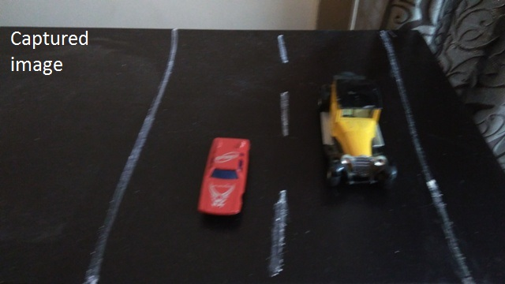 **.**

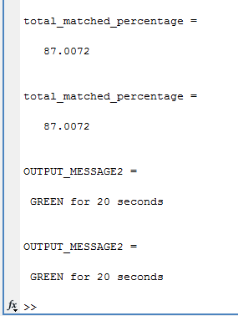

**CASE 5**



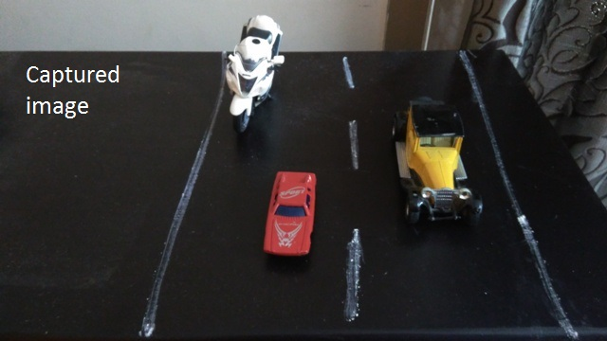

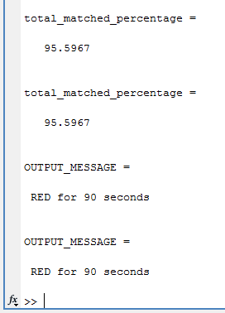

**5.2 EMERGENCY SERVICES**

Here , we detect an ambulance and allocate green light to that specific road irrespective of the traffic dendity.

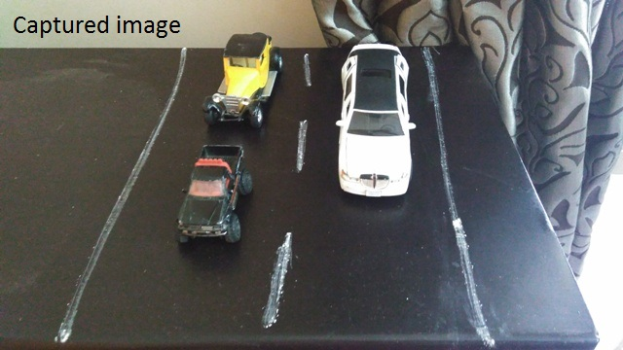

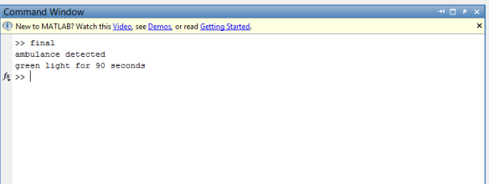

**5.3 ANALYSIS**

**CASE 1:**

The reference and the captured image have a percentage matching of 25% and hence, the output is green light for 90 seconds.

**CASE 2:**

The reference and the captured image have a percentage matching of 34% and hence, the output is green light for 60 seconds.

**CASE 3:**

The reference and the captured image have a percentage matching of 43% and hence, the output is green light for 30 seconds.

**CASE 4:**

The reference and the captured image have a percentage matching of 87% and hence, the output is green light for 20 seconds.

**CASE 5:**

The reference and the captured image have a percentage matching of 95% and hence, the output is red light for 90 seconds.

**EMERGENCY SERVICE:**

By counting the number of red pixels in an image and comparing it with the threshold , if the value is less than the threshold it implies that an ambulance is detected.

Thus we get an output of green light for 90 seconds irrespective of the density in the other lanes.